Passaggi
curated by Giovanna Calvenzi

May 17th – September 28th, 2013

Galleria del Cembalo
Largo della Fontanella di Borghese, 19
00186 – Rome

Hours
Tuesday – Friday: 4pm-7.30pm
Saturday: 10.30am-1pm; 4pm-7.30pm

Press Office
Peliti Associati

Roberta dal Verme
agenzia@peliti.it | tel. 349 6926944

Davide Macchia
macchia@peliti.it | tel. 06 52955548

The exhibition Passaggi inaugurates the Galleria del Cembalo, an exhibition space both new and ancient in the heart of Rome.
From the 17th of May to the 28th of September, twelve authors offer the opportunity to reflect on the vision of three generations of Italian photography.
Works by Olivo Barbieri, Gabriele Basilico, Antonio Biasiucci, Luca Campigotto, Silvia Camporesi, Mario Cresci, Ugo Mulas, Alice Pavesi, Paolo Pellegrin, Francesco Radino, Moira Ricci, Paolo Ventura.

The Galleria del Cembalo, new exhibition space opened upon initiative of Paola Stacchini Cavazza at Palazzo Borghese in the heart of ancient Rome, between the Spanish Steps and the river Tiber, returns to fans and art collectors some of the ground floor rooms decorated by Marcantonio IV Borghese in the late eighteenth century in order to house his own collection.
The exhibition’s central focus, conducted in collaboration with Mario Peliti, will be photography and its relationship with other forms of artistic expressions.
The inaugural exhibition, curated by Giovanna Calvenzi, is called Passaggi and from the 17th of May to the 28th of September aims to investigate, through the work of twelve photographers exposed in five large rooms, the theme of discontinuity, of need for change in language or of vision, which is distinctive in each work produced.
The idea, which is distinctive of humanistic photography and of part of the reportage culture, of an author who never changes and remains always identical in his photograph developing a recognizable style which describes in a unique way reality, is in contrast with conceptual photography in which there is the need for renewal, the expression of transition and sometimes of crisis, the exceeding of previous models and the use of new technologies.
The displayed photographs give evidence of the radical changes occurred with respect to previous experiences, of variations in the vision, of colour migrations, of a shift from an interpretation of reality to a manipulation of it or even changes in the daily life of the author expressed through photography: it is a vast overview, which aims to stimulate the visitor into understanding of different ways of creation, of image processing and of the artistic development of each artist.
Following this idea, in the exhibition each author - Olivo Barbieri, Gabriele Basilico, Antonio Biasiucci, Luca Campigotto, Silvia Camporesi, Mario Cresci, Ugo Mulas, Alice Pavesi, Paolo Pellegrin, Francis Radino, Moira Ricci, Paolo Ventura - presents two different series, in which the the 'transition' from one to the other describes the desire of conceptual photography of positioning each time differently with respect to itself and its subjects.
This transition is can be seen comparing Ugo Mulas’ series of photos, dedicated to Marcel Duchamp, that depict the history of New York (1964-1965) and still-life of Arnaldo Pomodoro’s jewellery creations on a woman's body (1968). The transition can also be perceived in all the other works displayed: Mario Cresci is on display with three series (1964, 1975-2011, 2013) that investigate, each from a different point of view, the relationship between the representation of reality and abstract images; Gabriele Basilico presents the opposition between the impressive cityscapes of Shanghai (2010) and the single building and to the silence of the deserted halls of La Biennale di Venezia (2012); Francesco Radino displays a work whose main feature is the powerful and monumental vision of turbine power plants (1984) and one which portrays an intimate Japan seen through the eyes of an European (1999); Olivo Barbieri exhibits his famous aerial views in which real locations look like plastic models (2007) and some metropolitan views which contain post graphic features (2011); Paolo Pellegrin exposes two different series in both cases Japanese, one that depict trees that trace the sky and the other passers-by that emerge from the darkness (2010); Antonio Biasucci presents a series that focuses on the home interiors of farmers living in Caserta (1982-1985) and one dedicated to the whirling kneading of bread dough (1990-1991); Luca Campigotto presents in his work the opposition between the dark views of the Port of Marghera (1996) and the coloured Chicago-Gotham City (2007); Paolo Ventura presents on one hand the unnatural realism of the reconstruction of the American Civil War (2010) and on the other self-portraits set in rarefied and full of pictorial references urban spaces (2011); Silvia Camporesi displays a series of self-portraits that have the Thirties’s aesthetics and feeling ( 2006) and the surreal and alienating visions of the Venetian lagoon (2011); Moira Ricci presents pre-and post-photographic manipulations of reality both in her domestic and loved theatres (2001) and in the self-representation of her fictional and painful memories (2004-2013); Alice Pavesi with a different approach, yet similar in the construction of the image, opposes the suffered white and black photographs in which she depicts Ethiopian women who have suffered violence (2009) with fashion shots carried out in a sought and simple environment (2012).
Passaggi also offers a view of the evolution of the photography culture in which the links, the cross-reference and the transitions are not only present internally between the two series exposed by each author, but also in connection to the different experiences on display, describing a lively and non-linear path of Italian photography that touches the past, the present and yet not predictable perspectives.
The exhibition is organized in collaboration with Peliti Associati.

Giovanna Calvenzi, after having taught for eleven years history of photography in a professional institute in Milan, since 1985 is photo-editor collaborating with several Italian magazines. From 2012 she is also image consultant for Periodici San Paolo. She teaches photo-editing and carries out an intense study on contemporary photography.

Paola Stacchini Cavazza has undertaken scientific studies, graduating in Physics at the University of Rome 'La Sapienza'. Between 1989 and 1992 she completed her doctoral studies at the University of Rome 'La Sapienza' University, Faculty of Engineering. Since 1992 she is Councillor of the Associazione Dimore Storiche – Sezione Lazio.

Mario Peliti, with a background as architect, founded in 1986, with his sister Francesca, 'Peliti Associati', a publishing house specialized in art photography which over the years has expanded its area of ​​expertise becoming also a public relations agency.
He created the European Publishers Award for Photography, an example of collaboration between independent publishers from different countries, which in 2013 celebrates the twentieth edition. He is the only western publisher to have commissioned a book to Helmut Newton. From 1995 to 2003 he directed the Galleria Minima Peliti Associati, an area of ​​only twenty-three square meters, which for several years has been 'the place' of photography in Rome.

Palazzo Borghese in the years

Whoever from the Spanish Steps goes towards St. Peter, walking through to Via Condotti, passes by the side of Palazzo Borghese.
The southern facade, which has an austere architectural composition composed by seven spans with a large door in the centre and a high frieze, dates back to the 1560s in the drawings of Martino Longhi il Vecchio inspired by Vignola.
Started upon order of Monsignor del Giglio, whose emblem is still visible in the courtyard, the building is still incomplete when Cardinal Pedro Deza replaces him in 1586. At his death, in 1591, the building became property of Cardinal Camillo Borghese in 1605 on the eve of his accession to the papal throne.

Thanks to a generous funding, Flaminio Ponzio completes the project and ends the construction. He decides on the new extended shape of the building that stretches out towards the river, beyond the area occupied by the square-shaped courtyard which is enriched by forty-eight ancient columns and three large statues.
The availability of the client and the talent of the great architect allow for the development of the building towards the Tiber, with the creation of the Ripetta wing which contains the roof garden, that proves to be an excellent way of protect the big inner Nymphaeum, decorated with statues and three fountains completed at a century later.

On the ground floor of the Ripetta wing a series of richly decorated rooms is created for Cardinal Scipione’s wonderful art colletion, which is subsequently transferred to the new Villa Borghese Gallery and then once again partially and forcibly moved to the Louvre Museum. The rooms for the large family, which were on the noble floors during summer and on the mezzanine in wintertime, were enriched with fresco painted ceilings commissioned to the best artists of the time. At the death of Flaminio Ponzio in 1613, most of the building was completed.
Carlo Rainaldi will then refine the roof garden and enrich Piazza Borghese’s facede with a magnificent portal on which stands the Borghese corps emblem, chiselled during the French Revolution years.
Following the end of Paul V’s pontificate in 1633, his nephew Scipione Borghese will take on the responsibility of completing his work, taking care of the building and of the immense number of properties around Rome.
In 1700 Marcantonio, brother of Cardinal Scipione, kept Palazzo Borghese’s reputation high, and the Palace soon became a mandatory place to visit for the upper-class men during their “Grand Tour” trip around Europe.
Marcatonio also commissioned to the artists who were already working on Casino of Villa Borgese (such as Gaspar Duguet, Caccianiga and Costantini) new decorations for the halls of the Gallery on the ground floor facing Ripetta.

The inauguration of the new headquarters of the Hunt Club in the halls of the first floor and the assignment of the Ripetta wing to the Embassy of Spain dates back to the 1920s.
The Palace regains its original splendour during the second half of the past century thanks to a series of renovation works of the building and the interior decorations. In 1960 the walls on the corner of Piazza Borghese are made more stable, in 1987 the entire length of the grand cornice is renovated and in 1997 the inner courtyard and nymphaeum are renewed, uncovering ancient stucco decorations and renovating fountains (awarded with Sotheby's prize for the best restoration).

La Galleria del Cembalo: description and history

In the wing of Palazzo Borghese that stretches towards the river Tiber giving to the building the unusual shape of a cymbal, on the ground floor there is a gallery which consists of five adjoining rooms, with fresco ceilings, overlooking the nymphaeum. From the entrance of the building on Largo della Fontanella di Borghese, the view of the magnificent fountains made by Rainaldi and of the hedges encourages to uncover the peace of the garden and leads to the entrance of the gallery.
A staircase leads to the spacious rooms, all with very high ceilings and a rich golden cornice that frame the painted walls, which immediately recall the “Grand Tour” era, during which the same rooms hosted visitors from all over Europe.

During that period, around 1770, Marcantonio IV Borghese, who was the head of the household and was very ambitious and wealthy, wanted to regain the importance and fame that the Borghese family had during the time of Paul V and his nephew Cardinal Scipione. In less than a hundred years, the Borghese family became one of the most important families of the Roman aristocracy and the rooms of the ground floor overlooking the garden a mandatory place to visit for travellers, who were welcomed in the gallery to admire the art collection, the sculptures and the paintings. The decoration of the rooms was done between 1767 and 1775 and, at the time, represented one of the most important decorative work in Rome of the late eighteenth, being commissioned to the most appreciated artists.

In the first room, on the ceiling there is Francesco Caccianiga’s painting Aurora, which was a common theme in the aristocratic buildings, which depicts the goddess while spreading flowers in the first light of day; moving on to the princess’ antechamber, there are neoclassical decoration done by Laurent Pécheux, in which in the center there is Le nozze tra Cupido e Psiche (1774) and on the side panels cards the wedding scenes with Jupiter, Mercury and the four elements.
On Piazza Borghese’s side there is the room which once served as prince Marcantonio IV’s antechamber that holds Ermenegildo Costantini and Pietro Rotati’s painting Ebe rapita dal Tempo (1769-70). From this room you then enter the Audience Hall, the largest and most outstanding room of the gallery, whose vault is decorated with Ermenegildo Costantini’s painting Il Trionfo dei Borghese e delle Arti (1773-74), which has been addressed by critique as “the final rumble of the Roman Baroque”. The family emblem is depicted as if it were in Heaven and crowned in a triumph of putti, amongst the Arts - sculpture, architecture, painting and music – and the Sciences, depicted by the side with a magnificence of colours and gold decorations.
In the last room, which points towards north, there is the Riconciliazione di Venere e Minerva painted by Pietro Angeletti (1773-1775) surrounded by monochrome panels depicting scenes from the Trojan War.

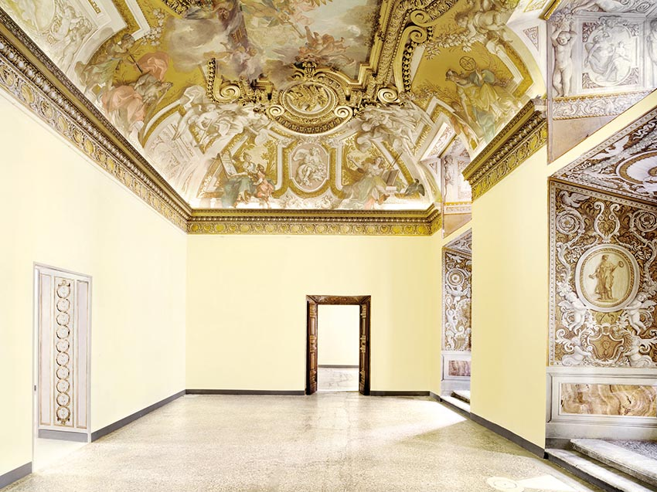

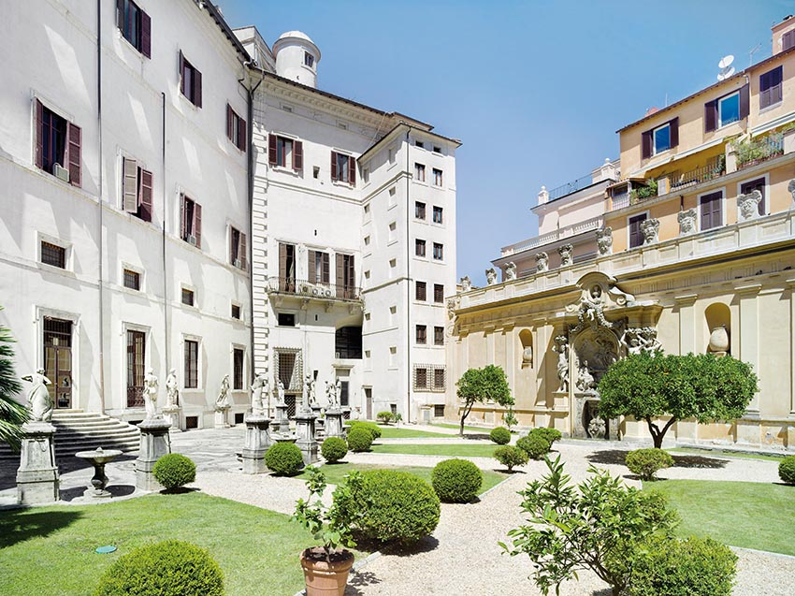

Galleria del Cembalo
Pictures of Massimo Siragusa

